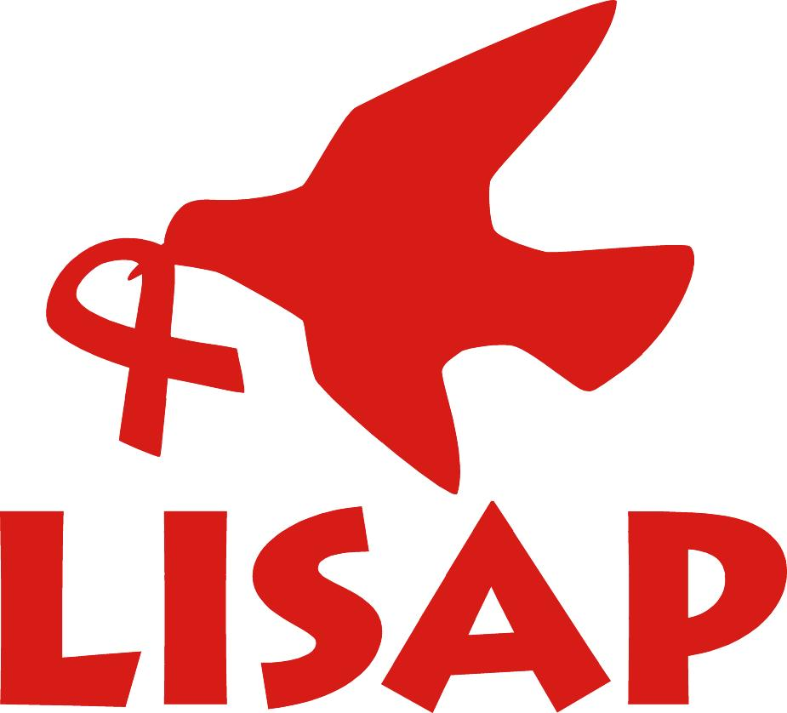
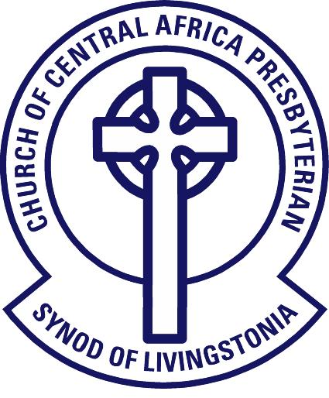
Livingstonia Synod
AIDS Programme

PO Box 279, Ekwendeni, MALAWI
Tel: +265 (0)1 339 265
Email: info@lisap.org.mw

REQUEST FOR PROPOSALS FOR THE PROVISION OF EXTERNAL AUDIT SERVICES FOR FINANCIAL YEAR 2018 TO 2020
Livingstonia Synod AIDS Programme LISAP was established in 1994 to develop the response of the church to HIV&AIDS to go beyond its 3 hospitals to reach the whole catchment area of the Church. Since then, the department has gained vast experience in working with communities to develop holistic programmes to address issues of HIV&AIDS.
We invite suitably qualified and duly registered practicing audit firms to apply for the provision of External Audit Services for a three-year contract renewable annually beginning financial year ending 31 December 2018.
Applicants must fulfil the following requirements;

- Read and understand the TOR’s
- External to CCAP Synod of Livingstonia.
- Provide evidence that the firm is legally registered with the Independent Regulatory Board for Auditors.
- Interested firms should provide the firm’s profile detailing the services offered.
- The Lead partners must have a minimum of 5years practising experience.
- Experienced in auditing Non-Governmental Organisations funded from a diverse of donors.
- Able to meet deadlines in producing the audited financial statements as per audit engagement letter.

A financial bid should be included in the proposal.
Shortlisted firms will be screened by the Board and Management subsequent to selection and appointment of one firm.
Submission of Requirements:
TOR’s can be sought from www.ccapsolinia.org/lisapccap or through contacts below

Sealed proposal documents clearly marked ‘Audit Services’ should be submitted before 1st October 2018 to;

The IPC Chairperson
Livingstonia Synod AIDS Programme,
P. O. Box 279,
EKWENDENI.
Email: info@lisap.org.mw
Further information in general and our previous audited accounts can be obtained from our website: www.ccapsolinia.org/lisapccap

