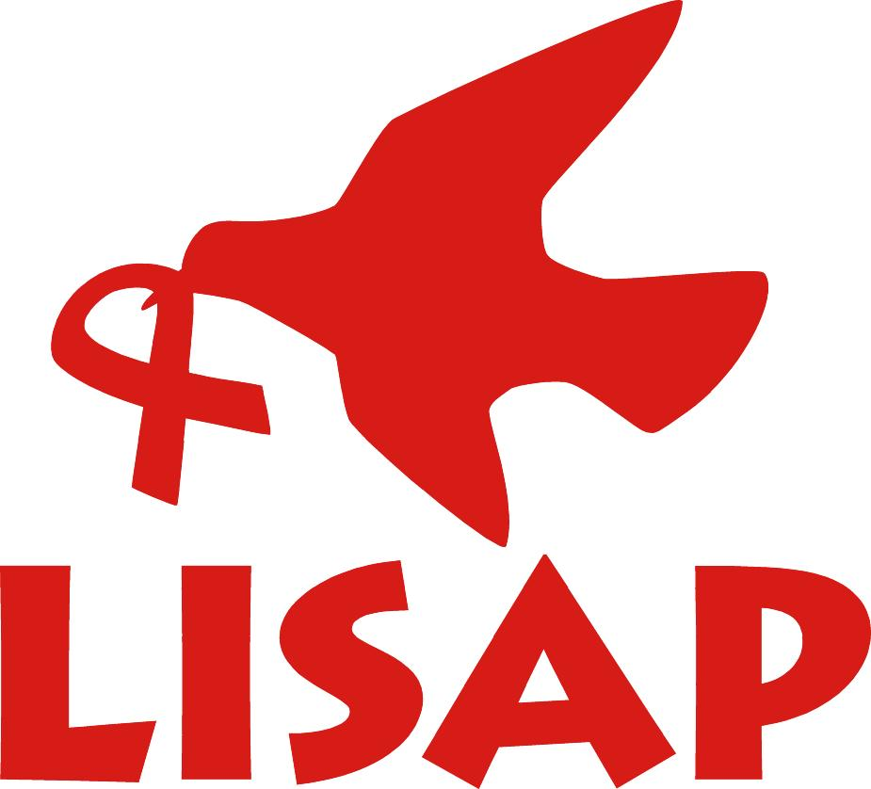

With funding from European Union (EU) through SAVE the Children International
(SCI), Livingstonia Synod AIDS Program (LISAP) is implementing a project in the five
districts of Northern Malawi called ‘Enhance Farmers Capacity To Scale Up Nutrition
In Malawi’. The project would like to get quotations for the supply of the following;

Commodity | Description | Qty
Lot A  Legumes | Soya beans seed  Ground beans seed  Ground nuts seed | 735 (5Kg packets)  370 (5Kg Packets)  735 (5Kg Packets)
Lot B  Fruits | Oranges seedlings  Paw paw seedlings  Molinga Seedlings | 1,470 seedlings  1,470 seedlings  1,470 seedlings
Lot C  Vines | Sweet potatoes | 735 bundles
Lot D  VSL Kits | Cash Boxes  Ledger Books  Bags  Calculators  Ink pads  Stamps  Pass books | 200  200  200  200  200  200  4000

Requirements
- Must be a registered company/individual as a supplier.
- Must be able to supply full quantity of the indicated lots.
- 100% payment after successful delivery of the supply.
- Must be able to deliver the products to the following TA’s of the five districts of
Northern Malawi – Chitipa (TA Mwenewenya, TA Mwenemisuku),
Karonga (TA Kyungu, TA Wasambo), Rumphi (TA Mwankhinkira, TA Chukulamayembe),
Nkhatabay (TA Kabunduli, TA Fukamapiri) and Mzimba (TA M’mbelwa, TA Mzukuzuku,
TA Jaravikuwa)
- Indicate total cost for the supply clearly showing unit cost.
- Indicate clearly and separately cost of delivery.
- Must be able to deliver within 30 days from date of contract.
- WHT shall be effected.

Interested bidders must send their ‘Tender Documents’ indicating the Lot Category with 2 traceable references to:
The Chairperson,
Internal Procurement Committee (IPC), LISAP, PO Box 279, Ekwendeni
info@lisap.org.mw, 01 339 265 / 0888 383 779
Closing date for receiving tenders: Monday 30th September 2018.
Only selected bidders will be notified.

LIVINGSTONIA SYNOD AIDS PROGRAMME (LISAP)

REQEST FOR QUOTATIONS (RFQ)

TO SUPPLY

LEGUMES, FRUITS, & VSL KITS

